TEACHER & INSTRUCTOR MANUAL
Soroban Abacus Classroom: Complete Teacher's Guide
Interactive Mental Math, Live Synchronized Classroom Management, Real-Time Student Telemetry & Curriculum Workflows
Web Application URL: https://www.aivacado.com/abacus | Target Audience: Math Educators, Abacus Senseis & Tutors
📌 ABOUT THIS MANUAL: This guide provides comprehensive instructions for math educators to run live interactive Soroban classes. It covers room creation, student invite links, live telemetry monitoring, real-time quiz broadcasts, and curriculum demonstrations using authentic 1:4 Japanese Soroban mechanics.

1. Introduction & Pedagogical Foundations
Overview: The Soroban (算盤) is the traditional Japanese 1:4 abacus developed to maximize mental calculation speed (Anzan) and visual-spatial arithmetic understanding. Unlike Western calculation tools, each vertical rod on a Soroban represents an exact base-10 decimal place value, partitioned by a horizontal reckoning beam into:
- • Upper Deck (Heaven Bead / 'Go-dama'): 1 bi-conical diamond bead with a value of 5. It is active when moved downward touching the reckoning beam.
- • Lower Deck (Earth Beads / 'Ichi-dama'): 4 bi-conical diamond beads each worth 1. They are active when pushed upward touching the reckoning beam.
- • The Reckoning Beam: Beads only hold value when touching this center beam. Any bead resting against the outer frame is considered inactive (0).
- • Unit Dot System: Small alignment dots on the beam designate unit (ones) columns. Rod #7 on the default 13-rod layout represents 10^0 (Units).
The Digital Advantage: The digital Soroban Classroom on Aivacado replaces fragile physical abacuses with a hyper-responsive, Web Audio-synthesized interactive board. Furthermore, it incorporates full real-time teacher-student telemetry, allowing educators to monitor dozens of students' abacus boards concurrently from any laptop, tablet, or smartboard.
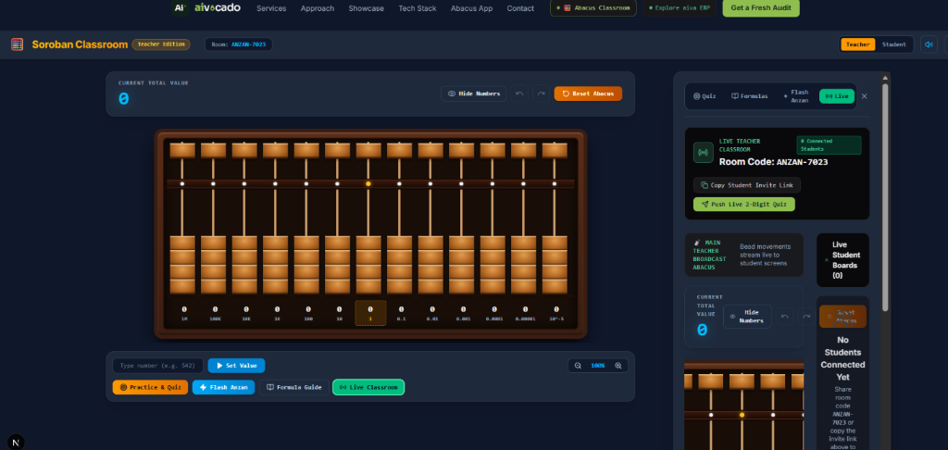
Figure: Soroban Classroom Teacher Interface featuring the 13-Rod Mahogany Abacus, Place-Value Indicators, and Live Session Controls.

2. Classroom Session Setup & Student Invitation
Quick-Start Flow: Setting up a classroom takes less than 5 seconds and requires zero student login or password creation. Sessions operate on isolated room codes that synchronize across normal tabs, incognito windows, mobile phones, and remote networks.
- Step 1: 1. Open https://www.aivacado.com/abacus in your web browser.
- Step 2: 2. In the top classroom bar, ensure the role switcher is toggled to 'Teacher' (highlighted in gold amber).
- Step 3: 3. Click on the Sensei name badge to personalize your instructor name (e.g., 'Sensei Tanaka' or 'Ms. Davis') and press Enter.
- Step 4: 4. A unique Room Code (such as 'SOROBAN-100' or 'ANZAN-7023') is generated automatically and shown in the header.
- Step 5: 5. Click the 'Copy Invite Link' button. This places a direct student link on your clipboard: https://www.aivacado.com/abacus?room=[ROOM_CODE]&role=student
- Step 6: 6. Share this link in your Zoom chat, Google Classroom, Microsoft Teams, or write the room code on your physical whiteboard.
📌 SESSION PERSISTENCE: Session Persistence: If you refresh your browser or accidentally close the tab, the classroom engine automatically restores your active Room Code, role, and custom teacher name from localStorage. You will not lose your session or disconnect your students.

3. Classroom Security, Screen-Share Safe PIN & Privacy
Security Architecture: To prevent students from unauthorized privilege escalation or snooping on peers' progress, the platform incorporates a zero-leak security architecture designed specifically for teachers who share their screen or projector:
- 1. Host Auto-Authentication: As the creator of the room, you are automatically recognized as the authorized teacher via a secure local key. You never have to manually enter a passcode to run your class.
- 2. Screen-Share Safe Masked PIN (••••): The 4-digit room passcode is hidden by default in both the top navigation header and the Live Drawer. When presenting your screen over Zoom, Microsoft Teams, Google Meet, or an in-class projector, students cannot read the PIN.
- 3. Eye Toggle & Clipboard Copy: An Eye button (👁️) allows you to reveal the PIN in private if needed. Additionally, a Copy button lets you copy the 4-digit PIN directly to your clipboard without ever displaying it visually on screen.
- 4. Student Privilege Lock: On student screens, the 'Teacher' button shows a lock icon (🔒 Teacher). Clicking it opens a secure modal requiring the 4-digit PIN. Without the passcode, students cannot access teacher mode, telemetry, or broadcast controls.
- 5. Server-Side Data Redaction: The backend API enforces roster privacy over the wire. If a student inspects network traffic using browser DevTools, the server completely redacts all other students' names, scores, and bead positions. Each student only receives broadcast challenges and their own data.
📌 SCREEN-SHARE TIP: Screen-Share Best Practice: Always keep the PIN masked (••••) when projecting your screen. If you need a teaching assistant or co-instructor to join with teacher privileges, copy the PIN using the copy button and send it to them via private chat.

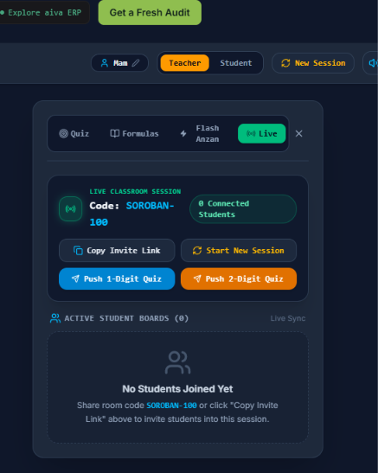
Figure: Live Classroom Drawer showing Room Code, Screen-Share Safe Masked Passcode (•••• with reveal and copy), and Live Student Roster.

4. The Teacher Workspace & Abacus Controls
The main workspace provides full manual manipulation and quick-input automation tools:
- • Direct Value Input ('Set Value'): Enter any integer or decimal (e.g. 542 or 3.14) into the input box below the abacus and click 'Set Value' (or press Enter). The digital abacus instantly animates the beads into the exact Soroban configuration.
- • Reset Abacus ('Clear'): Click the orange 'Reset Abacus' button to clear all beads back to 0. An authentic wooden rattle sound effect confirms the board is zeroed out.
- • Hide / Show Numbers: Click 'Hide Numbers' to conceal the numeric digit labels below each rod. This forces students to read the bead positions directly, reinforcing mental spatial pattern recognition.
- • Undo / Redo History: Step backward and forward through previous bead movements to review calculations with your class.
- • Adjustable Rod Count (5 to 17 Rods): Switch between 5, 7, 9, 11, 13 (Standard), 15, or 17 rods via the rod count dropdown to match beginner vs. advanced curriculum.
- • Visual Frame Themes: Choose between Classic Wood & Brass (traditional mahogany), Modern Dark (high contrast for smartboards), Midnight, or Bamboo.
- • Sound Effects Toggle: Toggle the audio synthesizer on or off. When enabled, every bead flick produces a natural, acoustic wooden clack.
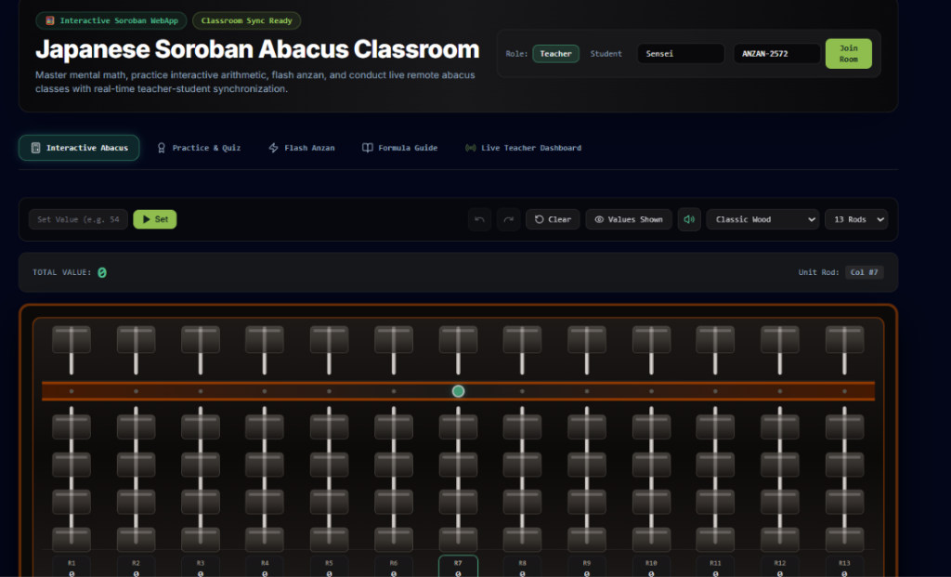
Figure: High-contrast Modern Dark theme displaying rod indices (R1-R13), unit rod indicator (Col #7), and clean place-value labeling.

4. Live Classroom Sync & Student Telemetry
Classroom Visibility: The standout capability of the Aivacado Soroban Classroom is real-time bidirectional telemetry. As a teacher, you never have to wonder if a student has set the correct beads on their screen.
- • Active Student Roster: Open the 'Live' sidebar tab to view every connected student card. The roster displays each student's name, their currently calculated abacus total, their cumulative quiz score, and their active answer streak.
- • Live Telemetry Polling: Students' boards transmit state updates every time beads are moved, with a 1.5-second heartbeat fallback guaranteeing sync across mobile and incognito clients.
- • Individual Student Inspector Modal: Click the 'Inspect' eye icon on any student's card to open an interactive modal showing that student's exact live 3D abacus beads in real time. You can instantly diagnose if a student misapplied a 5-bead or forgot to clear an earth bead.
- • Live Demonstration Broadcasting: When you demonstrate bead movements, the sync engine transmits your column configuration to all connected students so their boards mirror your instruction.

5. Pushing Interactive Quizzes & Challenges
Classroom Competitions: Keep students engaged with instant gamified challenges pushed directly from the Teacher Live Drawer:
- • Push 1-Digit Quiz: Broadcasts an instant single-digit challenge (e.g., 'Set 8 on the abacus') to all student screens simultaneously.
- • Push 2-Digit Quiz: Broadcasts a two-digit challenge (e.g., 'Set 74 on the abacus') to test tens and units coordinate movements.
- • Self-Paced Practice Modes: Students can also practice independently in three modes: 'Read the Number' (beads are shown, numeric value is masked with ❓ ❓), 'Set the Number' (target given, beads must be formed), and 'Mental Arithmetic' (solve equations).
- • Live Gamification: Correct answers earn +10 points (with streak multipliers) accompanied by rewarding audio chimes. Streaks of 3 or more trigger the Fire Streak badge.
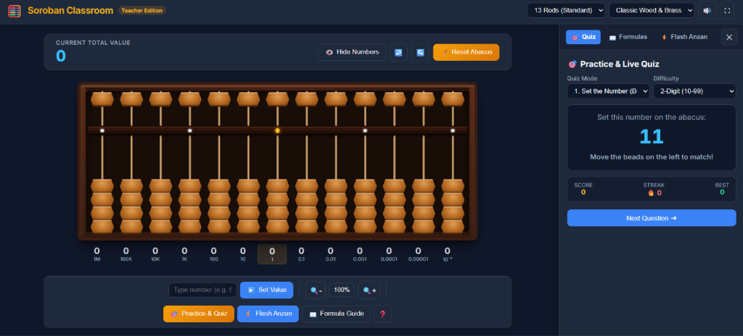
Figure: Practice & Live Quiz Mode showing masked answer prompt, streak counters, and real-time validation on the Soroban board.

6. Flash Anzan (Mental Math) Speed Drills
Pedagogy: Flash Anzan (フラッシュ暗算) is the world-renowned Japanese technique where numbers flash on the screen at rapid intervals and students calculate the cumulative sum entirely in their head by visualizing an imaginary Soroban.
- • Digits: Configure 1-digit (1-9), 2-digit (10-99), up to 5-digit numbers depending on student grade level.
- • Terms: Select how many numbers flash in sequence (typically 5 for beginners, 10-15 for advanced classes).
- • Flash Interval Speed: Adjustable from 2000ms (2.0s for young learners) down to 300ms (0.3s for rapid mental calculation).
- • Synchronized Acoustic Cues: Each flash plays an auditory click and countdown chimes, anchoring rhythm and focus.

7. The Interactive Formula Guide Module
Curriculum Reference: Teaching bead complements is effortless with the built-in Formula Guide. Click any formula to view the breakdown:
Category | Formula | Rule Description | Interactive Demo
Small Friends (+5) | +4 = +5 - 1 | Add 5 Heaven bead down, clear 1 Earth bead down | 1-Click Animate
Small Friends (+5) | +3 = +5 - 2 | Add 5 Heaven bead down, clear 2 Earth beads down | 1-Click Animate
Small Friends (+5) | +2 = +5 - 3 | Add 5 Heaven bead down, clear 3 Earth beads down | 1-Click Animate
Small Friends (+5) | +1 = +5 - 4 | Add 5 Heaven bead down, clear 4 Earth beads down | 1-Click Animate
Big Friends (+10) | +9 = -1 + 10 | Clear 1 on current rod, add 1 on Tens rod left | 1-Click Animate
Big Friends (+10) | +8 = -2 + 10 | Clear 2 on current rod, add 1 on Tens rod left | 1-Click Animate
Big Friends (+10) | +7 = -3 + 10 | Clear 3 on current rod, add 1 on Tens rod left | 1-Click Animate
Big Friends (+10) | +6 = -4 + 10 | Clear 4 on current rod, add 1 on Tens rod left | 1-Click Animate
Mixed Complements | +6 = +1 - 5 + 10 | Combine 5-bead and 10-bead borrowing | 1-Click Animate

Teacher Tip: Clicking 'Demonstrate on Abacus' next to any formula automatically animates the step-by-step bead movements on the main board, allowing your students to see the physical translation of the complement rule.

8. Recommended Lesson Structure (45-Minute Template)
Phase | Time | Activity | Application Tool
1. Warm-Up | 5 mins | Visual finger dexterity drill & zeroing board | Abacus Clear + Set Value
2. Flash Anzan | 10 mins | 5-term speed arithmetic (1-digit & 2-digit) | Flash Anzan Module
3. New Concept | 12 mins | Introduce a Friend formula (e.g. +4 = +5 - 1) | Formula Guide + Demo
4. Hands-On Practice | 10 mins | Students complete 'Set the Number' challenges | Practice & Quiz Tab
5. Live Competition | 8 mins | Teacher pushes 1-digit and 2-digit challenges | Push Quiz + Live Roster

9. Troubleshooting & FAQ for Teachers
- • Q: A student joined but their score/value isn't showing in the roster.
A: Have the student check their internet connection. The app polls every 1.5s; refreshing the student's tab will automatically rejoin the same room code.
- • Q: The audio clack sounds are not playing.
A: Modern browsers require an initial user click before enabling the Web Audio API. Simply clicking any bead or the sound toggle unmutes the synthesizer.
- • Q: Can I use this on an interactive smartboard or projector?
A: Yes! Click the Fullscreen button (top right) and select 'Modern Dark' theme for maximum visibility across large physical classrooms.

