STUDENT & LEARNER WORKBOOK
Soroban Abacus Classroom: Student Learning Guide
Master Mental Math, Bead Fingering Techniques, Flash Anzan Speed Drills & Interactive Quizzes
App Link: https://www.aivacado.com/abacus | Target Audience: Students, Young Learners & Self-Paced Math Masters
📌 WELCOME TO SOROBAN: Welcome to the Soroban Abacus Classroom! By learning to calculate on this digital abacus, you are training your brain to see numbers as pictures. Soon, you will be able to add and subtract big numbers faster than someone using a calculator!

1. What is a Soroban Abacus?
Fun Fact: The Soroban is a traditional Japanese counting frame that has been used for centuries. While modern calculators do all the thinking for you, the Soroban teaches your brain HOW numbers work.
Look at the abacus board on your screen. You will see vertical wooden rods with beads on them, split into two decks by a horizontal center bar (called the Reckoning Beam):
- 1. The Upper Deck (Heaven): Has 1 bead on each rod. This bead is worth 5! When you slide it DOWN to touch the center beam, it counts as 5.
- 2. The Lower Deck (Earth): Has 4 beads on each rod. Each bead is worth 1! When you slide them UP to touch the center beam, each one counts as 1.
- 3. The Reckoning Beam (Center Bar): The golden rule of Soroban is: Beads only count when they are touching the center beam! If a bead is pushed away towards the outer frame, it is ZERO (0).
- 4. The Unit Dot (Center Dot): Look closely at the center beam. You will see small dots. The middle dot on Column #7 is your ONES rod (1s place). The rod to its left is the TENS rod (10s), then HUNDREDS (100s), and THOUSANDS (1,000s).
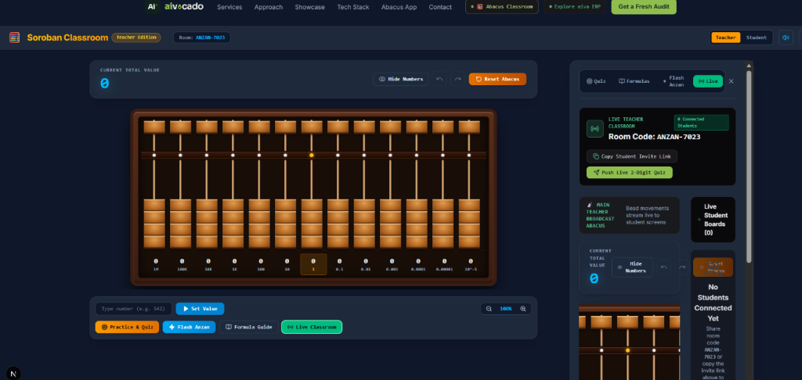
Figure: The Soroban Abacus Board. Notice the center dot on Column #7 (Unit / Ones column) and the upper Heaven beads.

2. How to Join Your Class (3 Quick Steps)
Joining your teacher's live classroom is super easy:
- Step 1: Go to https://www.aivacado.com/abacus (or click the invite link your teacher sent you). If your teacher gave you a 4-letter/number Classroom Code, simply click the blue 'Join Class' button in the top header (or click 'Change' next to the Room code), type the code (e.g. SOROBAN-4821), and hit 'Join Class'!
- Step 2: In the top bar, click on your name (next to the user icon 👤) to type your real name (e.g. 'Alex' or 'Maya') and press Enter.
- Step 3: Ensure your role badge is set to 'Student Mode'. In Student Mode, session management is handled by your teacher (no distracting 'New Session' buttons), so you can focus entirely on learning, challenges, and speed drills!
📌 AUTO-SAVE: Don't worry about losing your progress! If you refresh the page or lose your internet connection, the app will automatically remember your name, your room code, and your score.

📌 PRIVACY & SAFETY: Safe & Private Learning: Your abacus board and calculations are private between you and your teacher. Classmates cannot see your screen or tamper with your answers. Teacher controls are protected by a secure passcode so your class stays focused and organized.

3. Proper Fingering Technique (The Secret to Speed)
Champion Secret: Professional Soroban champions use a special two-finger technique to move beads with lightning speed. On a touchscreen or mouse, practice using these fingers:
Hand & Finger | Action | Beads Moved | Math Operation
Right Thumb 👍 | Push UP towards beam | Lower Earth Beads (+1, +2, +3, +4) | Adding 1 to 4
Right Index ☝️ | Pull DOWN away from beam | Lower Earth Beads (-1, -2, -3, -4) | Subtracting 1 to 4
Right Index ☝️ | Push DOWN towards beam | Upper Heaven Bead (+5) | Adding 5
Right Index ☝️ | Push UP away from beam | Upper Heaven Bead (-5) | Subtracting 5

4. Practice & Quiz Modes (Earn Points & Fire Streaks!)
Game Modes: Click the 'Quiz' button in the sidebar or below the abacus to start practicing. You can choose between 3 fun game modes:
- • Mode 1: Read the Number 🧐 — The app sets beads on the abacus for you, and hides the number with ❓ ❓. Look at the rods, calculate the value in your head, type your answer, and press Submit!
- • Mode 2: Set the Number 🎯 — The app gives you a challenge number (like 'Set 85'). You move the beads on the abacus to build 85, then click 'Check Answer'.
- • Mode 3: Mental Arithmetic ⚡ — The app gives you a math equation like '43 + 28'. Use the abacus beads to solve it and verify your answer!
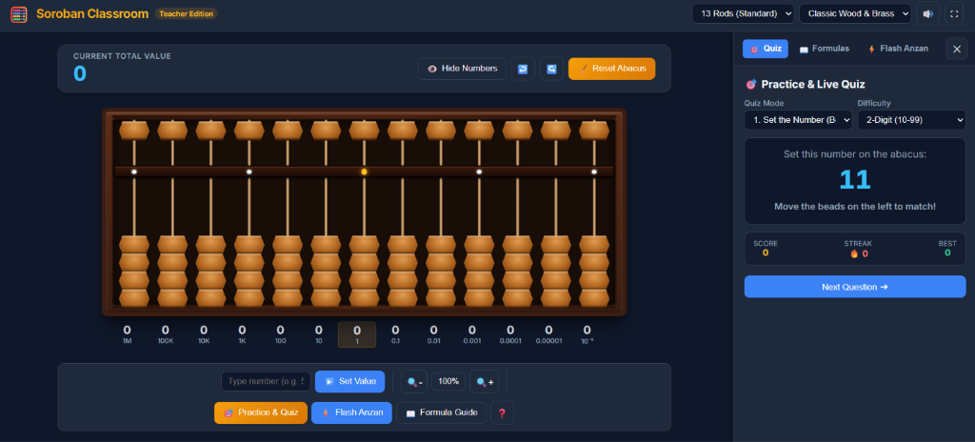
Figure: Practice & Live Quiz Mode with 'Set 11 on the abacus' challenge, Score counter, and Fire Streak badge.
📌 GAMIFICATION TIP: Fire Streak Bonus: Every time you answer correctly on your first try, your Streak increases by 1! If you get 3 in a row, you unlock the Fire Streak (🔥). See if you can get a streak of 10 or more!

5. Flash Anzan: Train Your Mental Superpower
What is Flash Anzan? Have you ever seen children on television add up 10 numbers in 3 seconds without a calculator? That is called Flash Anzan (Mental Abacus), and you can train it right here!
Here is how to play:
- 1. Click the 'Flash Anzan' tab in the sidebar (look for the yellow lightning bolt ⚡).
- 2. Choose your settings: Start with 1-Digit numbers, 5 Terms, and a Speed of 1.0 second (1000ms).
- 3. Click 'Start Flash'. A 3-second countdown will start: 3... 2... 1... GO!
- 4. Numbers will flash on your screen one after another. Do NOT write them down! Picture an imaginary abacus in your head and move the beads in your mind.
- 5. When the flashing stops, type your final total and click Submit. If you are correct, you will hear the victory chime! 🏆

6. Formulas Made Simple (Small Friends & Big Friends)
The Magic of Friends: What happens when you want to add 4, but you only have 2 lower beads left? Don't panic! That is where your 'Friends' help you out!

Small Friends (Numbers that make 5: 1+4, 2+3)
- • +4 Friend: If you cannot add 4 lower beads, push down the 5-bead and take away 1 (+5 - 1).
- • +3 Friend: Push down the 5-bead and take away 2 (+5 - 2).
- • +2 Friend: Push down the 5-bead and take away 3 (+5 - 3).
- • +1 Friend: Push down the 5-bead and take away 4 (+5 - 4).

Big Friends (Numbers that make 10: 9+1, 8+2, 7+3, 6+4, 5+5)
- • +9 Friend: Take away 1 on the current rod, and push UP 1 on the tens rod to the left (-1 + 10).
- • +8 Friend: Take away 2 on the current rod, and push UP 1 on the tens rod (-2 + 10).
- • +7 Friend: Take away 3 on the current rod, and push UP 1 on the tens rod (-3 + 10).
- • +6 Friend: Take away 4 on the current rod, and push UP 1 on the tens rod (-4 + 10).
📌 VISUAL LEARNER TIP: Need to see it in action? Click the 'Formulas' tab in the app. Click 'Demonstrate on Abacus' next to any formula to watch the beads move step-by-step!

7. Live Teacher Challenges & Demos
Connected Classroom: When your teacher is in the room, exciting things happen live on your screen:
- • Live Quiz Alerts: When your teacher pushes a challenge from their dashboard, your quiz tab will immediately pop open with the challenge! Solve it as fast as you can to show up at the top of the teacher's leaderboard.
- • Teacher Live Demonstrations: When your teacher demonstrates a problem, watch your abacus board closely—the beads will move in real time to show you the exact solution!

8. Student Daily Practice Routine (10 Minutes to Mastery)
- Step 1: Minute 1-2: Clear the board and practice setting numbers 1 through 9 on the unit rod.
- Step 2: Minute 3-5: Run 3 rounds of Flash Anzan at your comfortable speed.
- Step 3: Minute 6-8: Solve 5 'Read the Number' and 5 'Set the Number' quiz challenges.
- Step 4: Minute 9-10: Pick 1 Small Friend or Big Friend formula to practice 3 times.
Final Encouragement: Practice just 10 minutes every day, and within a few weeks you will be calculating faster in your head than your classmates can type into a calculator! 🌟

